**How to check if you purchased a yearbook (or just view your purchase history).**

**Go the Evergreen’s school website** <https://www.everettsd.org/Domain/13>

**Under Quicklinks, click on Payments Online**

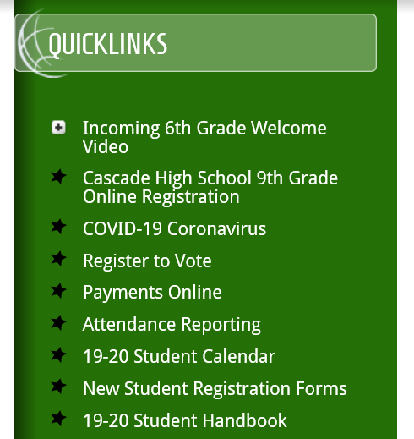

**From there, you will click the following link**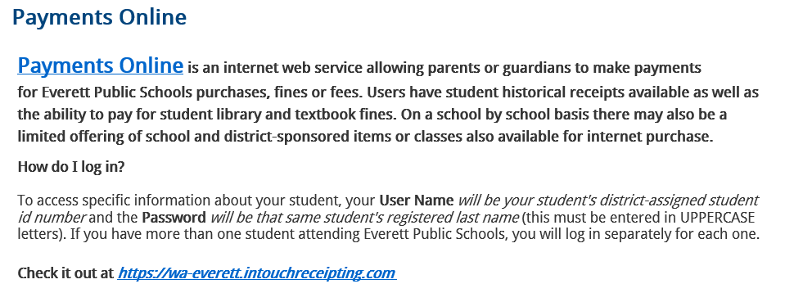

**This link takes you our online payments system login page**

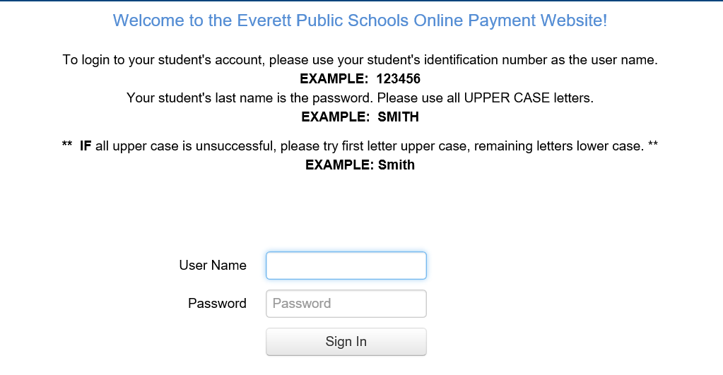

**Once logged in, you will click on your student’s name**

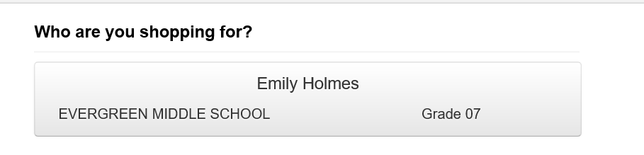

**From there, you will click Purchase History under Reports**

